- The drop in UK CPI inflation in April was larger than we had anticipated, reflecting smaller annual price hikes for many regulated prices. This development means we now expect a lower peak for CPI inflation this year.
- But we still think inflation will climb to 4% in H2 2026, as higher gas prices lift household energy bills over the summer and firms pass on some of the recent jump in input costs to consumer prices.
CPI inflation fell to 2.8% in April from 3.3% in March, below our forecast and consensus expectations. April’s drop was primarily driven by the services category, where once-a-year price hikes for index-linked contracts and regulated prices were smaller than expected. There was also downward pressure from the energy category, with Ofgem’s energy price cap having fallen by 7% on April 1. These movements more than offset a near 15% m/m rise in petrol prices in April. RPI and RPIX inflation both cooled to 3% in April, from 4.1% and 4% respectively in March.
Smaller increases for services where prices only change once a year will bake softer inflation into these categories until next spring. Movements in wholesale gas prices over the past month also point to a slightly smaller increase in the energy price cap in July. But the downward pressures on our forecast from these sources are mitigated by our higher assumptions for oil and gas prices in H2. This reflects our view that it will take longer for the volume of shipping through the Strait of Hormuz to return to more normal levels. This implies a higher energy price cap around the turn of the year. The net effect is a lower peak for inflation, though we still expect the CPI measure to reach 4% towards the end of 2026 and remain elevated for much of 2027.
Chart 1: Smaller annual price hikes in core categories have lowered our 2026 inflation forecast to 3.4%
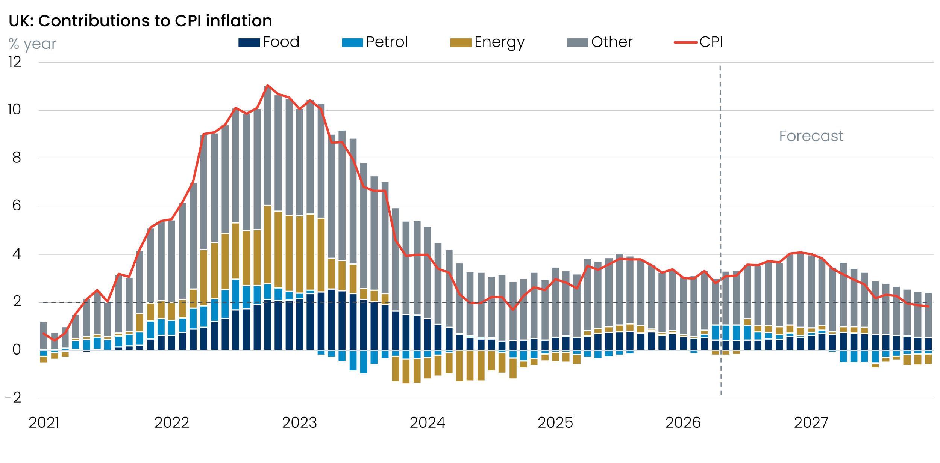
Sources: Oxford Economics, Haver Analytics

